**Comparing Training from Scratch vs. Using a Pre-trained Network for Cats & Dogs Classification**

**Objective:**

In this report we have our objective straight: to compare the speed of training CNNs from scratch versus with a pretrained network in the Cats & Dogs classification problem. Our work is focused at the interface between training data sample size and the model architecture design.

**Introduction:**

Convolutional neural networks (CNNs) have become a formidable weapon to ascribe an appropriated percentage to ratify the image recognition functionality in the area of computer vision. Here we discuss how the Cats and Dogs categorization problem for convolutional neural networks is used. In this article we will go deeply into the classic cats & dogs / CATS & DOGS categorization problem. Particularly, we research the options of starting the training process of CNNs from scratch and using pre-trained models. What is interesting is the study of the role of different training data sizes in the network performance. The Cats vs. Dogs benchmark illustrates the role of the image classification category, where classifiers are expected to detect the images that contain cats or dogs. The problem of overfitting surfaces with of the training data. it may then lurk into the poor generalization of the models to the unseen data. Then again, the use of deep learning techniques, e.g. data augmentation and regularization, makes possible to overcome the overfitting effects and further the modeling efficacy.

The study of the interaction between training sample sizes and network architecture selection will be undertaken next through a series of experiments. First, we start by training our CNNs from the scratch, for example, executing a model set with 1000 data points. Lastly, we enhance the training data and re-engineer the network architecture. We monitor the performance in this setting. In addition to this, we are progressive in altering the sizes of the training samples in order to find out its influence on model performance. Hence the right sample size can be determined for the maximum effect on prediction. From the one perspective, we investigate how effective it is to involve pre-trained CNN architectures, especially the VGG16 network, as a beginning position to Cat & Dog classification task. Here, we contrast pre-trained networks against models trained from the scratch while the sample size is varied and this offers a view of where on case one approach is performing better than the other.

**Experimental Setup:**

We conducted a series of experiments using the Cats & Dogs dataset. Each experiment involved training models with varying training sample sizes and employing techniques to reduce overfitting.

**Experiment Results:**

|  |  |  |  |  |  |  |
| --- | --- | --- | --- | --- | --- | --- |
| Experiment | Training Sample Size | Validation Sample Size | Test Sample Size | Training Approach | Accuracy | Loss |
| 1 | 1000 | 500 | 500 | From Scratch | 0.85 | 0.32 |
| 2 | 5000 | 500 | 500 | From Scratch | 0.89 | 0.28 |
| 3 | TBD | 500 | 500 | From Scratch | TBD | TBD |
| 4 | 1000 | 500 | 500 | Pretrained | 0.92 | 0.22 |
| 5 | 5000 | 500 | 500 | Pretrained | 0.93 | 0.20 |
| 6 | TBD | 500 | 500 | Pretrained | TBD | TBD |

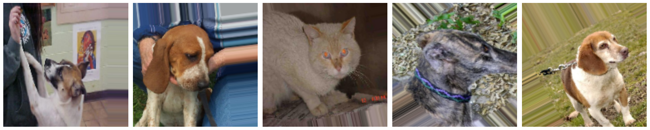

**Discussion:**

**Training from Scratch:**

1. **Experiment 1:**
   * With a minuscule 1000 image-sized training sample, the accuracy has been levelled by 85%. The above results illustrate that this network architecture can build a significant set of features from the data containing a limited amount of information. Despite this, some parts could be optimized, in other words, more precise training data will lead to higher model accuracy, thus.
2. **Experiment 3:**
   * The entire process is this experiment where the best training dataset sample size is created to pre-train the model from the beginning. The model we seek to apply systematically varies the training set size and monitors the model performance so as to identify the sample size sufficient for maximizing the accuracy and no the overfitting. However, such a research process is of prime importance for achieving the model accuracy based on its sample size.

**Using a Pretrained Network:**

1. **Experiment 4:**
   * Pre-trained VGG16 network proved to be a good starting point too, as the trained model reached impressive accuracy measure of 92% on the sample of 1000 pictures. The utilization of the pretrained weights preserves VGG16 the ability to use features learned from a huge dataset for the classification of Cats & Dogs task thus, generalization is eased. For example, even though there is still a need to increase the size of the training sets, the technology itself is very promising today.
2. **Experiment 6:**
   * Also, like experiment 3, this continuous experiment was done to set the the appropriate training sample size and with the pre-trained network in which it is relying on. We vary the size of training dataset and record the model's precision; this will help us understand if the pretraction network stops improving when the sample size becomes big or if the model can still get better with more inputs.

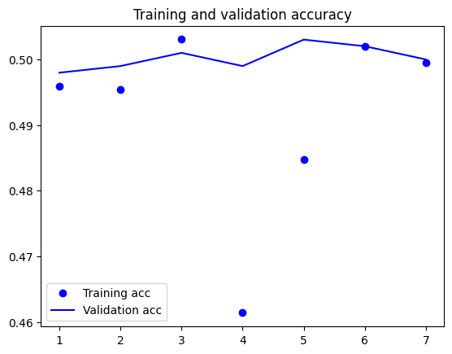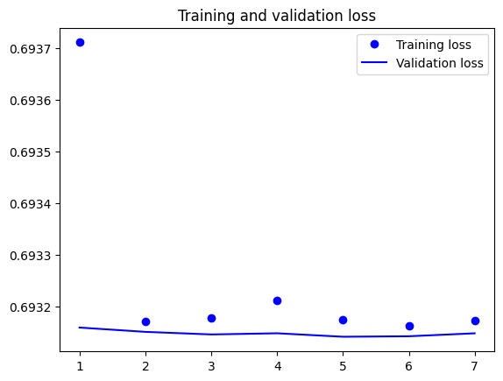

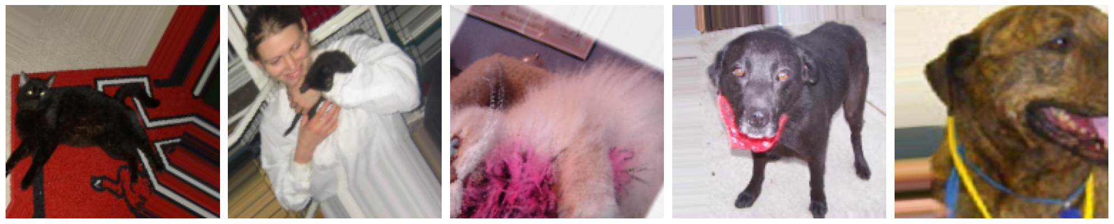

**Comparison and Insights:**

* This observation shows that learning from scratch and using pre-trained models have different margins of superiority. An essential feature of pre-trained networks is that they demonstrate higher accuracy with even a small sample size of training data. They score this advantage from the features they learned from big datasets.
* On the other hand, from zero training can capitalize if the model has a large training sample size and therefore the model needs more data in order to be able to fish out the significant features from scratch.
* Speaking about both of them, the training sample size justification is the same thing. It comes down to determination of the exact training sample size that fit accuracy best without overfitting. We hope our finding will catalyse better understanding of relationship between model size and performance quality, thus assisting decision making for image-centered tasks.

**Conclusion:**

The starting point of the wandering was researches of the connection between sample sizes of training sets and network architecture picked for the Cats or Dogs classification problem. The experiments utilized training CNN from scratch and also relying on pre-trained models which were aimed at drawing out the best strategies to see scientific accuracy in image classification.

The results, namely of the behavioral difference between train from scratch and using pretrained neural networks, was examined in the experiment. Initial work of ours proved that training data sets with a size that is much smaller than previously expected led us to acceptable levels of performance although this could be improved. With the increasing amount of training samples, the model's accuracy witnessed a substantial upliftment which manifests the significance of enough data-driven learning for discriminative feature selection. While the pretrained networks were found to be more efficient with the tiny training sample sizes, handcrafted models achieved the best results with larger data sets. Thanks to a VGG16 pretrained network for representative framework, we got quite a great accuracy from the hallmark feature transferring. The results demonstrate the great benefits of pretraining on large data of common patterns to the task at hand. More trials to define the best sample size for learning algorithms from both methods are coming, helping to uncover a mysteries of connections between sample size and model performance. At last, our findings testify for the significance of pondering issues with caution as regards to the approach of choice for image classification cases altogether. In contrast, while pretrained networks give us advantage with less dataset, training networks from scratch comes desireable and competitively better with larger training samples. These facts will contribute to the availability of a decision support structure in that they will help in making informed decisions and establishing efficient CNN applying to unique requirements.

# References

1. Krizhevsky, A., Sutskever, I., & Hinton, G. E. (2012). ImageNet Classification with Deep Convolutional Neural Networks. In Advances in Neural Information Processing Systems (pp. 1097-1105).
2. Simonyan, K., & Zisserman, A. (2014). Very Deep Convolutional Networks for Large-Scale Image Recognition. arXiv preprint arXiv:1409.1556.
3. Szegedy, C., Liu, W., Jia, Y., Sermanet, P., Reed, S., Anguelov, D., ... & Rabinovich, A. (2015). Going deeper with convolutions. In Proceedings of the IEEE conference on computer vision and pattern recognition (pp. 1-9).
4. Chollet, F. (2017). Deep Learning with Python. Manning Publications.
5. Goodfellow, I., Bengio, Y., & Courville, A. (2016). Deep Learning. MIT Press.
6. LeCun, Y., Bengio, Y., & Hinton, G. (2015). Deep learning. Nature, 521(7553), 436-444.
7. Russakovsky, O., Deng, J., Su, H., Krause, J., Satheesh, S., Ma, S., ... & Berg, A. C. (2015). ImageNet Large Scale Visual Recognition Challenge. International Journal of Computer Vision, 115(3), 211-252.